Management Information Systems, 16E

Laudon & Laudon

Lecture Notes by Barbara J. Ellestad

Chapter 7 Telecommunications, the Internet, and Wireless Technology

Anytime, anywhere, anyway, is the mantra of many computer users. Improved telecommunications technologies, the process of electronically communicating information, are making it possible.

Looking for an example of how much this revolution is touching every aspect of how we work, live, play, and learn? Look no further than this page—you wouldn’t be reading this if it weren’t for telecommunication networks!

7.1 What are the principal components of telecommunications networks and key networking technologies?

This section shows you how these networks are actually constructed and discusses the various elements involved in connecting all these computers. Knowing how it all works can give you insight into the changes that have taken place and an idea of what the future holds. You can also get ideas about how you can take advantage of the future now!

Networking and Communication Trends

For the most part, all of us have grown up with separate service providers and networks for our land-based telephones, cellular phones, and computers. We’ve been used to the idea that television cable service was separate from landline telephone service. Radio was separate albeit free. Cellular telephone services were separated from all of them. Now all of these telecommunication services are converging on the Internet and either blurring or destroying the lines of demarcation. It will become harder to determine where one ends and another starts as high-speed broadband network connections continue to expand and companies continue to develop products that meet consumer demands.

What Is a Computer Network?

Before we go much further, let’s make sure you understand how computer networks are configured. Figure 7.1 shows a simple network structure.

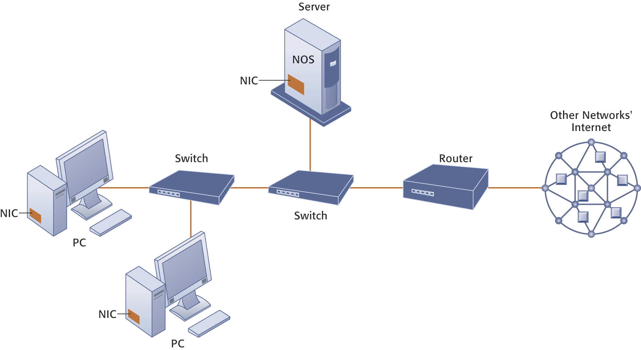

Figure 7.1: Components of a Simple Network.

What you should keep in mind is that you can continually add components to this kind of network and expand it exponentially. You can take a simple desktop computer and by way of a Network Interface Card (NIC), incorporate it into an existing network. To share network resources such as printers, and to route communications on a LAN, you require special software called a network operating system (NOS). Hubs and switches help route traffic on the network to the right computing device. When two or more networks are connected to each other, you need a router that sends data transmissions to the correct network device. Very large networks may require multiple routers so transmissions flow more quickly.

Because of the ever-growing complexity of networks, a new approach is available for managing their configurations called software-defined networking (SDN). Network administrators use the software installed on inexpensive commodity servers to manage traffic loads in a more flexible and efficient way.

Networks in Large Companies

Compare Figure 7.1 above that diagrams a simple computer network to Figure 7.2 that diagrams a corporate network infrastructure. You’ll see that the network you might use in a large company isn’t all that different from what you might use in your home. Obviously, there will be more computing devices and servers, but basically, you’ll have the same network infrastructure.

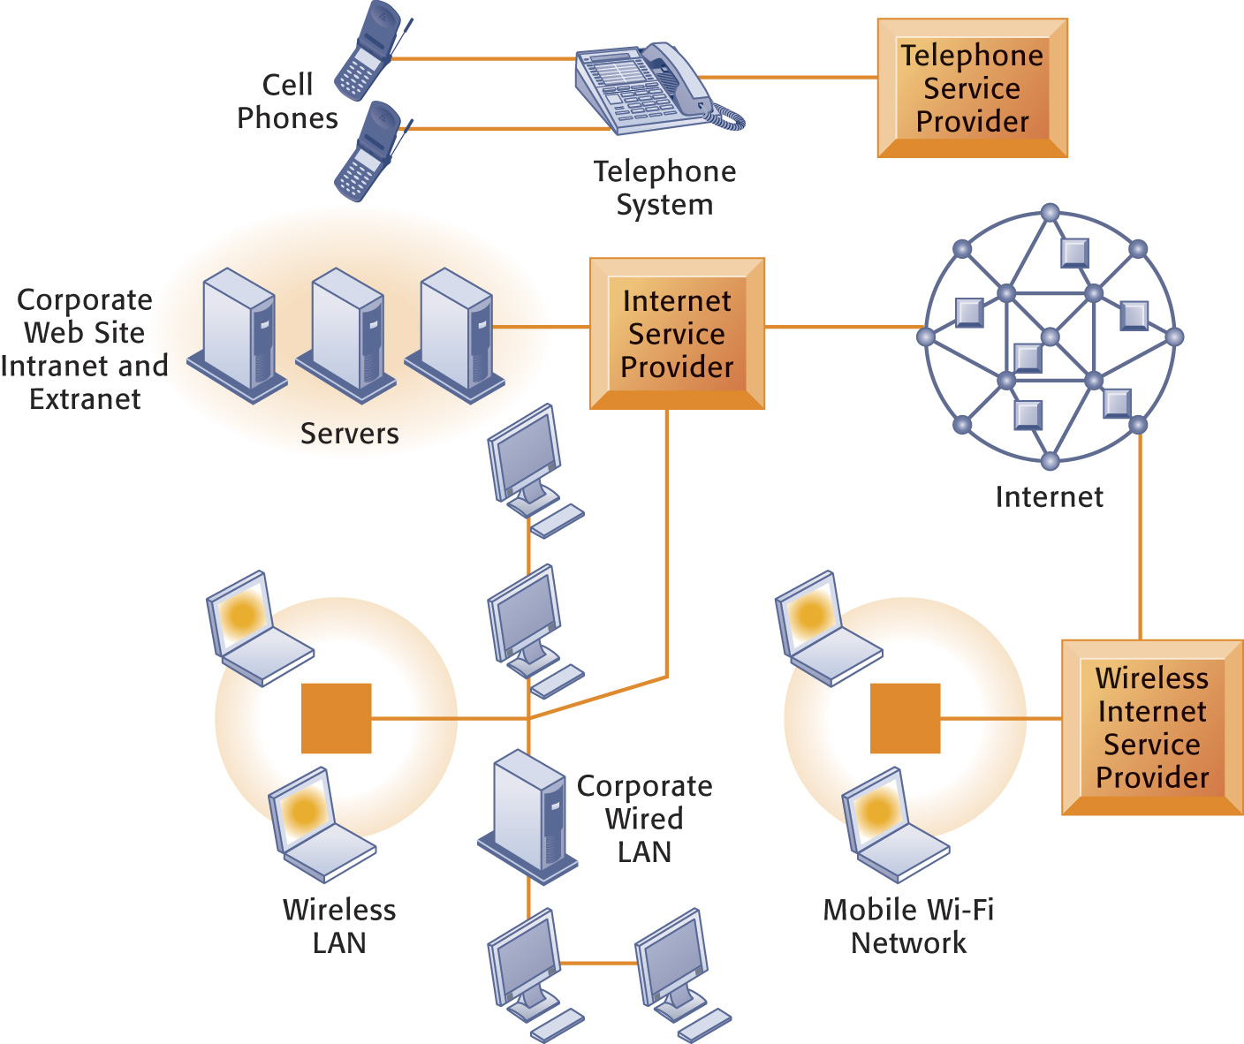
Figure 7.2: Corporate Network Infrastructure.

Most corporations, large or small, will use a combination of public and private transmission mediums, including networks built separately for voice communication and computer transactions. Slowly, the separate networks are converging into one network that can transmit any type of data generated by any type of device.

Key Digital Networking Technologies

Let’s look at three key technologies necessary for network computing.

Client/Server Computing

The client/server network facilitates computing on all kinds of networks including the Internet. Instead of one huge mainframe with individual nodes, smaller computers called servers connect to many clients. This type of network is ideal for companies that are continually expanding their networks or replacing hardware components.

Packet Switching

Think about going to the grocery store and buying a week’s worth of food. For some of us that may be 20 packages of Ramen noodles; for others that could be quite a bit of food. You buy all the things, load them all into your cart, and head for the checkout line. You pay for your food while it’s being bagged. Assuming you bought lots of items, not all of them are packed into the same bag. You might have four or five bags, maybe more. You take them home, unpack the bags, and reassemble all your goods in the cupboard. You’ve just experienced packet switching.

Packet switching is a method of breaking large blocks of data into smaller chunks and routing them in the most economical way through whichever communication channel is available.

When you access this lecture file on the web, it appears as though all the data came into your client computer together. But they didn’t. The data were broken into small packets on their way out of the server computer and then sent to and reassembled on the client computer. It happens so quickly and so efficiently that you don’t even notice. Packet switching also checks for transmission errors when data travel from one location to another.

TCP/IP and Connectivity

How does your Internet Service Provider manage to send your e-mail to the right place? We’re talking millions and millions of people sending e-mail and using the World Wide Web every day. How do you keep from getting Mary’s e-mail intended for Billy in Atlanta? Notice that each computer user connected to a network has a separate, individual address. No two addresses are exactly the same. All of these addresses are stored on various computers placed around the networks. Software stored on routers uses these addresses to route the data to the right location. Routers use protocols to help route data around the many networks to get them to their correct destination.

The most popular model for connecting networks is the Transmission Control Protocol/Internet Protocol (TCP/IP). Even though this protocol was originally created for what we now call the Internet, it is easily transferred to networks of all sizes. It provides the easiest methodology for communicating between computers through standardized protocols that ignore the hardware and software platforms of the individual pieces of equipment.

Companies can create web-based interfaces for different databases for data input/output and accessing information without actually combining the data physically in one huge computer. They do so by using TCP/IP models. With these protocols, they can reduce the disruption to the organization and decrease the overall costs of adding to their network.

This diagram shows you how TCP/IP works.

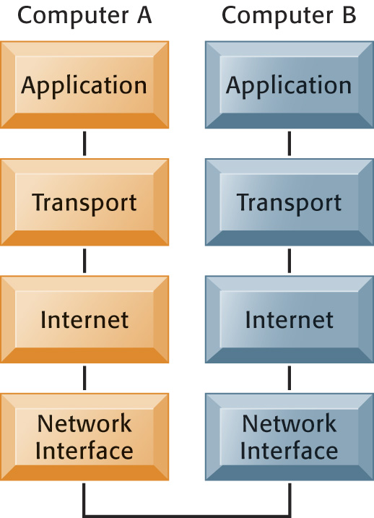

Figure 7.4: The Transmission Control Protocol TCP/IP Reference Model.

The most important benefit of the TCP/IP model is that it allows two computers to communicate even if they are based on different hardware and software platforms.

Bottom Line: All computer networks are basically the same. Many small networks can be connected to form larger networks, which in turn can be connected to the Internet. Protocols are the rules used in networks to ensure that transmissions can pass between the various components. The world of telecommunications and networking has changed drastically over the last ten years. If the pundits and experts are correct, and there’s no reason to believe they aren’t, we haven’t seen anything yet!

7.2 What are the different types of networks?

It’s likely that as a company grows, so will its networking needs and capabilities.

Signals: Digital vs. Analog

Everything going into a computer system must be transformed into the digital signals of the computer. That is, a computer understands only zeros and ones. However, in the networking world much of the data are transmitted over telephone lines. These lines don’t recognize zeros and ones. They understand only what are called analog signals—continuous waveform signals. To change the signals back and forth between analog and digital transmission methods, you need a modem.

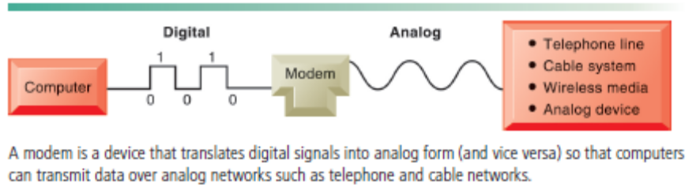
Figure 7.5 Functions of the Modem

Types of Networks

There are many different types of networks that organizations can use to connect their employees, managers, customers, suppliers, and business partners. It’s important that the right one is used.

Local Area Networks

The local area network (LAN) is probably the most common network setup. You can have as few as two computers or as many as you can possibly wire together in the local area. Other devices such as printers and even network-enabled pianos can be a part of a LAN. You can set up a LAN for local area processing within your company and then connect it to a larger outside network that could be linked to distant locations.

Many small businesses choose to forego a client/server network architecture in favor of a peer-to-peer network in which all the computers on the network are equal. Data on one computer can be accessed easily by any other computer. Setting up a small network with this configuration saves the cost of having a separate server computer.

Metropolitan and Wide Area Networks

A wide area network (WAN) is basically the same thing as a LAN, only for a broader geographic setting. This network is not limited by space and distance, and WANs use a combination of technologies to connect all the distant locations. A WAN may take on a derivative name such as MAN (metropolitan area network) simply to describe its physical location.

Transmission Media and Transmission Speed

Some experts call us a wired nation. If you consider all the methods we use to communicate, we should be referred to as a wireless nation. Our paging systems and cellular telephones use microwave and satellite technologies to transmit our voice and data communications from one place to another. We have cell phones, personal communication services (PCS), mobile data networks, and personal digital assistants (PDAs) to help us compute on the go. Now when people say they are “going to the office,” it could just as well be their car or truck!

All the transmission channels discussed in this section combine to give you what seems to be a single clear channel from one physical location to another physical location. In fact, it is very likely that when you access the Internet and call up a web site you are using a combination of twisted pair wire, fiber-optic cable, microwave stations, and satellites to transmit data from your computer to another computer.

Table 7.2 provides a description and speed of each type of transmission medium you may use when communicating from one point to another.

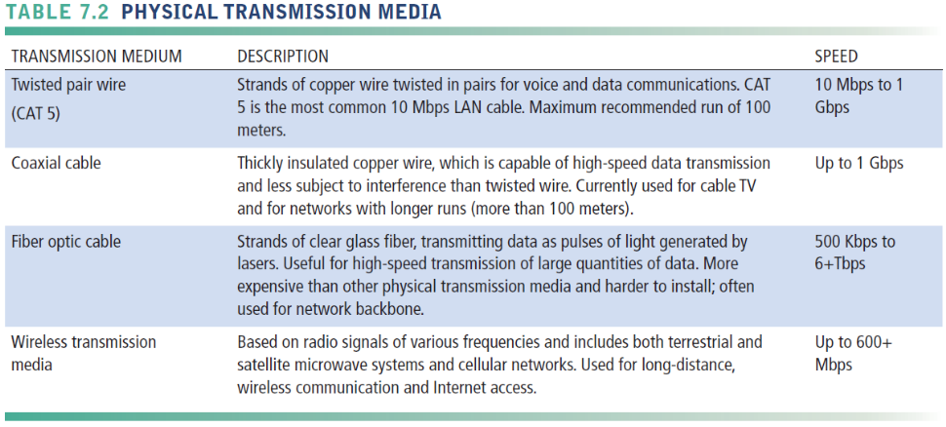

Bandwidth: Transmission Speed

When you transmit the latest information from a web site to your personal computer, the speed at which it moves across all the transmission media is measured in bits per second (BPS). The speed at which the bits are transmitted in each cycle is referred to as hertz. If you transmit one million bits in each cycle, you would call that rate megahertz (one million bits per a single cycle). The bandwidth of a communication channel is measured by the difference between the highest and lowest frequencies that can be transmitted by that channel.

Bottom Line: Communication channels consist of wired and wireless media. Processors and software are combined with the protocols and transmission media to form a network. There are many different types of network infrastructure configurations. Which one is best for your organization depends on your situation. Many new network services are being introduced to increase the speed of network access and will probably reach your world in the next few years.

7.3 How do the Internet and Internet technology work and how do they support communication and e-business?

The latest research numbers from the Pew Internet web site show that 89 percent of American adults (including 97 percent of Americans age 18 to 29) use the Internet. (Pew Internet, http://www.pewinternet.org Dec. 2018)

Try picking up a newspaper or magazine, listening to the radio or television, or simply talking to people, and you’ll be hard-pressed not to hear something about the Internet and how it’s changing businesses and the way people buy and sell items.

What Is the Internet?

The Internet was developed in 1969 for the U.S. military and eventually spread to universities and civilian researchers. Because of its open structure, interest in its use began to grow beyond these exclusive groups. Internetworking is the idea that computer networks are connected to other networks allowing data to flow freely.

The Internet is best described by what it isn’t. There is:
- No single computer
- No single control source
- No single owner
- No single entry point
- No single type of application

The Internet consists of computer networks spread all over the world, through wired and wireless transmission media, which contain software codes that allow them to talk to each other. That’s it. If you tried to find a single “front door” to the Internet, you’d be looking for a long, long time.

Small businesses and individuals connect to the Internet through Internet Service Providers (ISP) such as Earthlink or CoxMedia. In many areas the ISP is a small local company connected to a larger network. With recent mergers in the entertainment and Internet industries, some cable TV companies such as TimeWarner may serve as the ISP for home users.

One way of physically connecting to the Internet is with a Digital Subscriber Line (DSL). It uses regular telephone lines to carry both voice and data transmissions at very high speeds.

Because many home computer users already have cable TV installed in their homes, the telecommunications industry is using cable Internet connections to pump data into the home. If you have many people on the same cable line, each individual accessing the line will notice progressively slower speeds as the number of users increases. It is much faster than a dial-up modem, though.

Larger organizations, such as universities and corporations, can afford a T1 line, which supports extremely high rates of data transmission. These lines are capable of carrying voice and data transmissions over 24 channels, which make them ideal for larger networks. Because they are expensive, it’s not something you’d install in your home.

Internet Addressing and Architecture

Every address used on the Internet whether it’s an e-mail address or a web site address is nothing more than a series of numbers called an Internet Protocol address or IP for short. Computers spread out around the Internet and various networks convert the series of numbers such as 195.128.15.11 to an easily readable address such as www.USAToday.com.

The Domain Name System

The Domain Name System was devised because it’s much easier for people to read letters and words than to work with series of numbers. The DNS uses a hierarchical breakdown of addresses as Figure 7.6 shows.

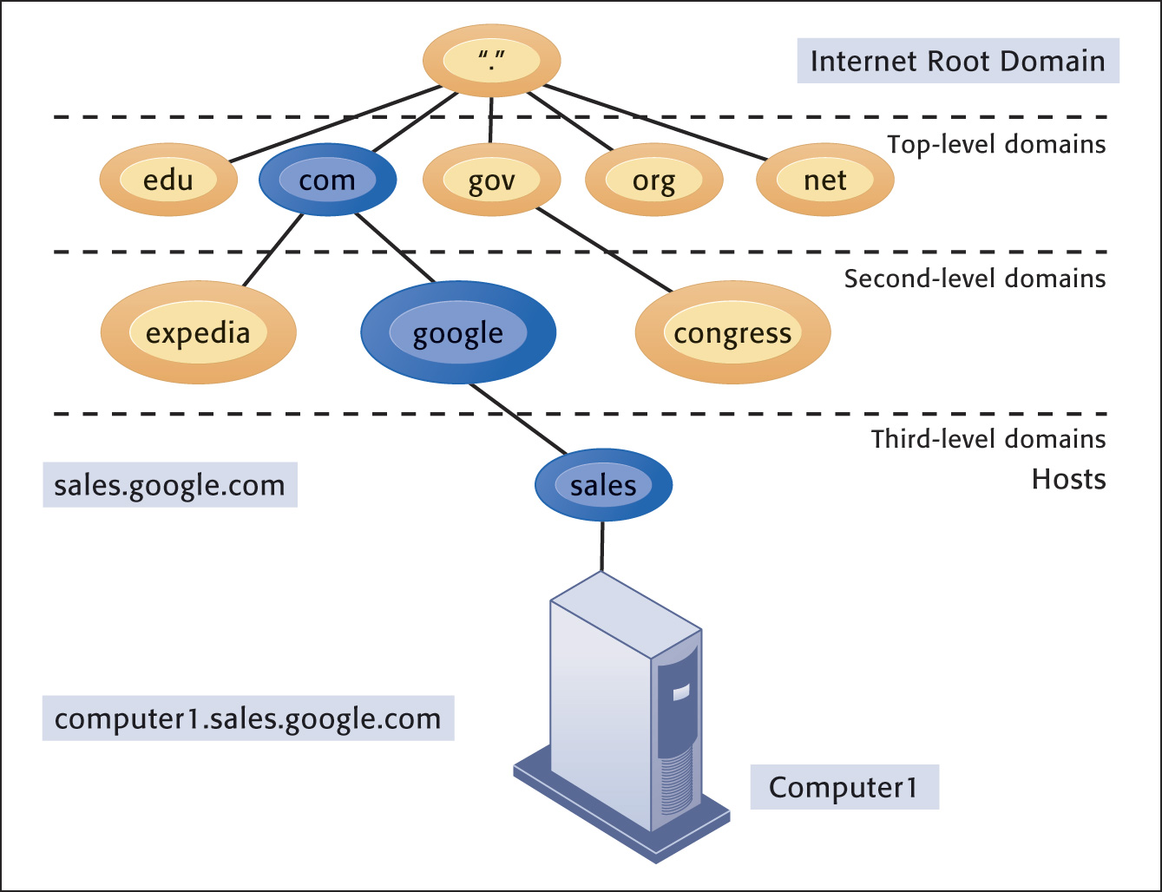

Figure 7.6: The Domain Name System.

Domain names used in e-mail addresses and web site addresses are easily obtained through several services such as www.networksolutions.com and www.register.com. How do you get a domain name? Be the first to request a unique name and pay the required fee. That’s all there is to it.

Internet Architecture and Governance

Even though no one owns the Internet as a whole, parts of it are owned and controlled by many different private and public entities. Network channels in the United States are largely private whereas in other foreign countries, for example China, the government owns the backbone. To ensure continuity and connectivity throughout the world, various organizations have been established to help administer the Internet:

- Internet Architecture Board: defines the overall structure of the Internet
- Internet Corporation for Assigned Names and Numbers (ICAAN): assigns IP addresses
- World Wide Web Consortium: sets standards for the web

Just remember, no one owns it. And, it’s not free.

Interactive Session: Organizations: Net Neutrality: The battle rages on (see p 265 of the text) introduces arguments for charging Internet users based on the amount of transmission capacity they use. There are some very good points made for both proponents and opponents.

The battle of net neutrality has raged for years and it will only continue as consumers and businesses increase the amount of data they transmit over the Internet. Internet Service Providers (ISP) will face challenges in keeping up their infrastructures to meet the growing demand. As the article below explains, competition among businesses for eyeballs is at the heart of the debate.

“Say you'd like to get a cheeseburger. So you get in your car, spend a few minutes fiddling with the Bluetooth and starting a good snacktime playlist, then turn on the ignition. You back out of the driveway and hit the road, but which one?
Recently, all of the old streets and highways have been torn up and replaced with roads that run only to individual businesses. McDonalds pays a high toll, so it has a nice boulevard with ample space and speed limits that would make Andy Green hang up his spurs.
Frank's Burger Joint does not, so its street has one unpaved lane with a speed limit of 25, a pothole known as the Void of Destiny and traffic cameras that sell your image for Russian social media bot profiles.
According to the Highway Department there's no problem because both restaurants have a road. Still, while Frank makes the best burgers in town, getting there is an enormous hassle. You haven't been there in months.
Welcome to the post-net neutrality world.
Net neutrality is the principle that an internet service provider (ISP) has to provide access to all sites, content and applications at the same speed, under the same conditions without blocking or preferencing any content. Under net neutrality whether you connect to Netflix, Hulu, TheStreet or a friend's random blog, your ISP has to treat them all the same.
Basically, Comcast can't choose where you go online.
The goal of net neutrality is to ensure that businesses can compete freely on the internet without having to pay gatekeeper tolls. Without it consumers would look more like advertising segments than an open marketplace.” (What Is Net Neutrality and Why Is It Important in 2019?, www.thestreet.com, Reed, Eric, Dec 27, 2018)

The Future Internet: IPv6 and Internet2

As the Internet and other networks continue to proliferate, it’s becoming very difficult to work with the limited number of IP addresses available in the old system. Therefore, new IP addressing schemas are being developed along with an expanded Internet architecture. IPv6 is an initiative designed to increase the available IP addresses to handle the burgeoning number of users on the Internet.

If experts’ predictions are correct about the increasing usage and reliance on the Internet, and there’s no reason to believe they aren’t, we need to improve and change the current configuration to meet future demand. The Internet2 project may help. The Next Generation Internet project has similar goals of advancing the use of the Internet in ways that will enhance our lives. Here’s how the Internet2 web site (http://www.internet2.edu) describes itself:

“Internet2 is a member-driven advanced technology community founded by the nation’s leading higher education institutions in 1996. Internet2 provides a collaborative environment where US research and education organizations can solve common technology challenges and develop innovative solutions in support of their educational, research and community service missions. Our community touches nearly every major innovation that defines our modern digital lives—and continues to define “what’s next.””

Don’t worry that personal users of the “old” Internet will be left behind. New technologies developed for Internet2 and NGI will trickle down to the traditional Internet and make it easier for everyone to use.

Internet Services and Communication Tools

With the recent introduction of new communication and information appliances, such as smart phones, PDAs, cell phones, and mobile data networks, organizations have found it necessary to upgrade their networks to incorporate these new technologies.

Internet Services

We keep complaining about information overload, yet we crave more. The Internet provides access to data about any topic you can imagine through software-based services such as discussion groups, newsgroups, chat functions, instant messaging, Telnet, and FTP (file transfer protocol). Keep in mind that false information is as readily available as is true and correct information. Just be careful about the source of information you access.

The most useful feature of e-mail is the ability to attach files to a message and send them to colleagues anywhere in the world. This feature alone makes it a valuable tool for telecommuters and for collaborating with coworkers, wherever they may be. Unfortunately, the effectiveness of e-mail as a viable communication tool is diminished by spam and junk mail. The sheer numbers of e-mail message sent are overwhelming some corporate e-mail servers. Some businesses are now encouraging “no e-mail Fridays.”

Companies are using chat and instant messaging as a viable alternative to e-mail.

Use one of the search engines or directly access a popular portal page such as www.yahoo.com or www.msn.com and you’ll probably see a link to instant messaging services. Most IM services let you set up private chatrooms and will tell you when family, friends, or colleagues are online so you can “talk” to them. Some cell phones also allow you to send and receive IM messages from wherever you are.

Interactive Session: Management: Monitoring Employees on Networks: Unethical or Good Business? (see p 270 of the text) discusses both sides of a very sticky situation between employers and employees. It points out the need for every company to have corporate policies regarding employee use of e-mail and the Internet.

Voice over IP

Internet telephony services such as Skype.com have vastly improved over the last few years and are now becoming a popular way for a growing number of people to communicate over the Internet. The VoIP (Voice over Internet Protocol) technology threatens traditional telephone companies unless they adapt their business model to include this technology. You make long distance telephone calls free (from PC to PC) or for a much reduced price (PC to regular telephone) using this technology.

Here is an excerpt from the web site, VoIP-Info.org that will help you evaluate VoIP for business uses:

“Quality business VoIP providers today offer a wide variety of feature packages, services and prices. Selecting the ideal provider and service options will depend on your type and size of business, features needed and projected volume of usage. These metrics determine if you are better off paying per minute, per user, per line, or per feature. Before choosing your VoIP provider, it is essential to first determine your company’s precise telecommunications needs. A current phone bill or CDR record is a great place to find the information you need to compare providers. the basics you will need are: quantity of phone numbers, toll free numbers, user extensions, lines, calling usage for local, long distance and toll-free calls as well as and special feature to enable timely and cost-efficient initiation of your service.
With an excellent quality VoIP system installed and running well in your company offices to provide remote access for you and your employees, you can work much more efficiently, achieving more in less time. You will enjoy the many benefits of knowing that you can leave the responsibility of your advanced office telecommunications system operations to your VoIP provider while you handle other important business matters. (http.www.VoIP-Info.org, copied March 17, 2019)
(http://www.einfoxp.com, copied Nov 2012)

The important thing to remember with all this new technology is that nothing is standing still. The telecommunications and computer industries are working at breakneck speed to improve technologies in order to improve the networking experience not just for companies, but also for home users. By combining all the divergent networks into converged networks, businesses are able to save money. More importantly, they are able to offer more efficient use of all the new technology.

Unified Communications

You use e-mail. Then you switch to the telephone. Then you move to electronic conferencing. On to instant messaging. Each of these has a separate channel and separate platform. Don’t you wish you could merge them all into one unified communication package and save yourself time, aggravation, and headaches? Now you can thanks to a single universally accessible service that lets you switch back and forth between all these methods of communicating with others. The quote below shows how one company, Cisco is combining many different communication platforms in one consolidated service.

“Cisco Unified Communications Manager is a reliable, scalable, and integrated communication and collaboration solution that enables organizations and teams to facilitate interaction and engagement from a single tool which can be accessed on any device and any location. The solution combines voice and video calling, messaging, call and session management, and mobile features and capabilities.
Cisco Unified Communications Manager is built based on an infrastructure that integrates various communication systems in a unified platform. The solution combines voice and video calling, messaging, call and session management, and mobile features and capabilities. With its mobility features, users will be able to work anywhere they want, helping them improve their productivity. Whether businesses and enterprises are operating on a local or global scale, Cisco Unified Communications Manager provides tools that can adapt to their needs.
In addition, it supports integration with third-party business applications to ensure that team members are able to seamlessly collaborate with each other regardless of the tools they are using. Last but not least, it offers features that enhance data security and compliance.” (Cisco Unified Communications Manager Review, https://reviews.financesonline.com, accessed April 13, 2019)

Virtual Private Networks

Companies all over the world are building virtual private networks (VPN) to help reduce costs and make it easier for customers, suppliers, and employees to communicate. And why not? The Internet technology offers organizations a much cheaper alternative to the high cost of building and maintaining their own technology or using other technologies that aren’t built on the open standards of the Internet. VPNs also offer companies an extra layer of security protection through the tunneling process because of the “wrapping” effect not offered with generic transmissions.

The Web

In 1989, a scientist named Tim Berners-Lee created a software program to help him keep track of his personal information. He eventually offered the software to other users and called it the World Wide Web. In 1991, commercial use of the Internet was permitted for the first time and that’s when its use started to explode. In 1993, Netscape Communications Inc., was formed by Marc Andreeson and Jim Clark to market a new software application for the web called a browser. This graphical user interface allowed users to maneuver around web sites using a point-and-click method instead of textual commands.

The World Wide Web is a vast repository of data and information connected through hyperlinks. When you think about the fact that it didn’t even exist 25 years ago, it’s amazing to realize how much it has permeated everything we do in our personal and business lives.

Hypertext

We discussed protocols before: the rules by which data are transmitted over networks. The Hypertext Transfer Protocol (http) is what allows the web to operate. When you see a Uniform Resource Locator (URL) address on a web site, it will generally start with http://www. Most software browser programs now automatically insert that for you so you can simply enter the domain name of the web site you want to access—businessweek.com, for instance. A URL that begins with https indicates a site using secure socket layers that offers more secure transmission protocols than the plain http.

Web Servers

All web sites are stored on web servers scattered throughout the Internet. Rather than a small business owning and maintaining their own web server computers, they can pay a web hosting service to maintain the site. It’s often cheaper and easier and the small business doesn’t have to worry about downtime, scalability issues, or security.

There is a difference between a web site and a web page. A web site has the short domain address, such as www.prenhall.com. It is the central repository for many, many individual web pages that are included at the end of the address after the domain name and a slash. For example, www.prenhall.com/paper.html is a web page within the web site for Prentice Hall. A web page is a single document stored within the web site and probably linked to other pages on the site. Generally the home page is the first page you’ll see when you initially access a web site. It’s usually identified through the file name index.htm or default.html.

Searching for Information on the Web

Search engines and directories use various methods to help you find information on the web. You shouldn’t restrict yourself to just one or two search engines, but should try many different ones. You may be surprised at the different results you’ll get using the same keyword search.

Some search engines use special software programs to monitor the web for new or updated sites or pages. When they reach a new site or page, they analyze the contents and determine the correct category in which it will be listed. They then add it to their database so that it will appear on the search result list when someone enters the appropriate subject. You can search for FTP sites, videos, blogs, newswires, business news, stock quotes, and weather using these search engine capabilities. Figure 7.12 below diagrams how the Google search engine operates behind the scenes.

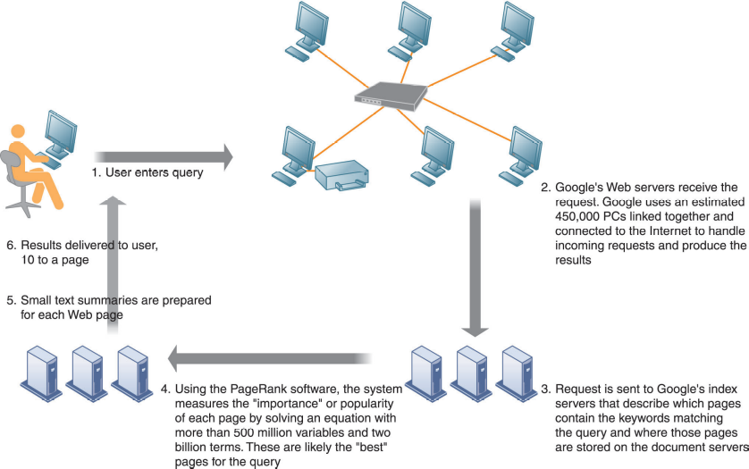

Fig 7.12 How Google Works

When you’re shopping for products in a brick-and-mortar store, how many times have you wondered if the price on that new bicycle is the best you can get? With mobile search capability on your smartphone or tablet, you can access other stores or dealers and determine on-the-spot if you’re getting the best deal. Mobile search also comes in handy if you’re trying to find restaurants, hotels, or popular sight-seeing spots in an unfamiliar area.

"Mobile to overtake fixed Internet access by 2014" was the huge headline summarizing the bold prediction from 2008 by Mary Meeker, an analyst at Kleiner Perkins Caufield Byers who reviews technology trends annually in May. Eric Schmidt of Google exhorted businesses to take a 'Mobile First' approach to designing web experiences.
Today, according to the latest Digital Future in Focus report from comScore, we're long past this tipping point in some countries with India, Mexico and Indonesia having more than up to 4 times higher smartphone vs desktop audience.
However, we need to be careful with interpreting data on hours spent, since we spend most of our time on smartphones checking email and using social media. This has led to the common mantra of 'Mobile-First' design which I think is dangerous, or at least oversimplistic! Eric Schmidt, then Chairman of Google talked about a Mobile-First approach. The reality is that while smartphone use is overwhelmingly popular for some activities such as social media, messaging and catching up with news and gossip, the majority of consumers in western markets also have desktop (and tablet) devices which they tend to use for more detailed review and purchasing. So, we need to think about strategies to engage what comScore call the Multichannel Majority not simply 'mobile first' or 'smartphone adoption'. This explains why mobile conversion rates are much lower in retail and why the breakdown between traffic for retail sites is broadly equal between smartphone and desktop. (Mobile Marketing Statistics compilation, www.smartinsights.com, Chaffey, Dave, July, 11, 2018)

Search result listings show you which web sites contain information related to your search words or phrases. The listings may also include sponsored links to sites related to your search request. Sponsored links are part of a burgeoning business known as search engine marketing. It provides businesses a new way to connect to potential customers through the special links at the top of the search result list or a special box on the right side of the search result page. Each time a user clicks on a sponsored link, the advertiser pays a fee to the search engine.

Because most people tend to stick to the first ten results of a search list, it’s important that webmasters and site owners do what they can to have their sites listed as close to the top of the list as possible. Search engine optimization is the art and science of creating web sites and pages so that happens. For instance, if your web site is devoted to selling African violets, you can include keywords in your home page in such a way that your site will rank higher than others in search results. Another trick is to link your site to similar sites devoted to the same subject—link your site to the African Violets Society of America’s site.

Sometimes search engines can be too thorough or too mechanical in producing results for search phrases. Social search uses results of your friends’ searches, their friends’ searches, and recommendations from other people to produce results of a search query rather than using mathematical algorithms. Chances are greater that you’ll get more relevant site listings.

Let’s assume you want to find the specifications online of an Apple iPad so you can compare it to an Amazon Kindle. You enter the search term “iPad specifications” in Google’s search engine and voila, you get a hundred suggested sites to purchase the product rather than the specifications themselves. Google is working hard to fix that problem through its development of semantic search. Its goal is to build a search engine that understands human thoughts and phrases rather than just finding words in its database. It’s also working hard to improve its search engine results to return videos and pictures that may be relevant to your search.

Much of the new data being created, used, and searched is in the form of visual and audio content, not just text. Visual web content and visual web search has become more important. Think Pinterest.com, Instagram, and other sites whose content is primarily photos and videos.

Many search engine home pages such as altavista.com have shopping bots available at a single click. Other shopping bot sites such as www.pricingcentral.com gather information from many sources and combine it for ease in comparing prices and availability. Keep in mind that some of the prices available through these kinds of sites may not be the absolute lowest you could find on your own. Some companies pay a service fee to the shopping bot sites to have their products listed regardless of whether they are the lowest price. Buyer, beware.

Sharing Information on the Web

You don’t have to search for information at all if you don’t want. Perhaps you’re an avid reader of blogs about golf. Rather than checking the entire blogosphere every day for new information, you register your information needs with an RSS (Real Simple Syndication) service. When new information is available, you’ll automatically receive a notification on your desktop similar to the newscast ticker tapes you see on your television screen. What began as a convenient method of receiving blog updates has now spread across a variety of news, sports, and information services to provide a convenient method of staying connected. Twitter.com produces microblogging posts that are limited to 140 characters.

Wikis are becoming a popular way to share information among employees, managers, suppliers, partners, and even customers. For instance, your collaborative team is devising a new advertising campaign. You have lots of input that previously was passed around the team via e-mail. But that’s unwieldy and doesn’t give any of your team members a convenient method of searching for information. Who wants to sort through 83 e-mails looking for one piece of information?

Instead your team could use a wiki to post ideas, information, or details of the latest version of your campaign in one consolidated location. All your team members could post comments, edit comments from others, and collectively store all the files associated with the project. Searching for a particular piece of data is easy and fast. Wikis are much easier to use than more sophisticated knowledge management systems and the software is much cheaper.

What started out as a way for teenagers and college students to connect to their friends online and share photos and gossip, is now a multi-billion dollar social networking industry embraced by the likes of IBM, Ford Motor Company, and Coca-Cola. They have gone far beyond simply staying in touch with a few dozen—or few hundred—friends to an almost necessity in corporate life.

Here are a few tips from the Australian government for businesses who want to use social networking and social media to reach out to their customers and users:

Pros of social media
Social media can have the benefits of word of mouth, but on a larger scale and reach a high number of potential customers.
Potential advantages can include:
- reduced marketing costs
- increased sales
- increased traffic to your website
- improved ranking on search engines
- greater customer engagement
- greater access to international markets
- opportunity for customer feedback
- opportunity to conduct market research about your customers
- improved networking opportunities with customers and other businesses.

Cons of social media
Social media may not be suited to every business. If you are unprepared and launch your social media presence without proper planning, you could waste valuable time and money.
Some of the possible disadvantages you should be aware of are:
- Not having a clear marketing or social media strategy may result in reduced benefits for your business.
- Additional resources may be needed to manage your online presence.
- Social media is immediate and needs daily monitoring.
- If you don’t actively manage your social media presence, you may not see any real benefits.
- Greater exposure online has the potential to attract risks. Risks can include negative feedback, information leaks or hacking.

Around seven out of ten Americans (69%) use social networking sites such as Facebook, Instagram, Twitter, LinkedIn, and Pinterest, as of 2018, up from 26% in 2008. On social media sites, users may develop biographical profiles, communicate with friends and strangers, do research, and share thoughts, photos, music, links, and more.
Proponents of social networking sites say that the online communities promote increased interaction with friends and family; offer teachers, librarians, and students valuable access to educational support and materials; facilitate social and political change; and disseminate useful information rapidly.
Opponents of social networking say that the sites prevent face-to-face communication; waste time on frivolous activity; alter children’s brains and behavior making them more prone to ADHD; expose users to predators like pedophiles and burglars; and spread false and potentially dangerous information.

Social networking sites are a top news source for 27.8% of Americans, ranking below newspapers (28.8%) and above radio (18.8%) and print publications (6%).

Students who used social networking sites while studying scored 20% lower on tests and students who used social media had an average GPA of 3.06 versus non-users who had an average GPA of 3.82.

35 global heads of state, every US Cabinet agency, 84% of US state governors, every major candidate for US President, and more than 40% of top global religious leaders are on Twitter.

10% of people younger than 25 years old respond to social media and text messages during sex.

In July 2012 Americans spent 74.0 billion minutes on social media via a home computer, 40.8 billion minutes via apps, and 5.7 billion minutes via mobile web browsers, a total of 121.1 billion minutes on social networking sites. (Are social networking sites good for our society?, socialnetworking.procon.org, copied March 17, 2019)

The Future Web

The old saying “a picture is worth a thousand words” is now playing out on the Internet with popular sites such as Pinterest and Instagram. These sites are not just for individual use; businesses can benefit from them as well if they use the features correctly.

You’ve probably heard about Instagram and what it can do in marketing a business. And I bet you are now wondering if you should be using Instagram as a social media marketing platform for your business.

A lot of business owners are using this platform because of the advantages it can bring to their business.

Now, maybe you’re thinking of using Instagram too as a social media marketing platform for your business. If you have that thought right now, then you should definitely do it.

When we started marketing online, we didn’t pay Instagram too much attention. We were primarily focused on Facebook because that was what we knew.

Turned out that was a huge mistake.

Just like any other social networking platforms, there are pros and cons of using Instagram. This shouldn’t be much of a deal because there’s no such thing as “the perfect platform” to market your business.

You just need to plan on how to get the best of using Instagram and avoid the potential problems of its flaws. (The Advantages and Disadvantages of Instagram for Business, www.mikemarko.com/advantages-disadvantages-of-instagram, Marko, Mike, March 22, 2019)

Businesses and organizations generate so much data with all the new technologies now available. They want to put the data to good use to improve operations and profits. But it’s a lot of data – hence the name ‘Big Data.’

Wireless sensor networks and other networks send their output over an “Internet of Things” for analysis. Any object that generates data can be the focus of the Internet of Things (IoT). So many computing devices now include sensors that collect data and make it available in many different forms of information.

Other trends pointing towards the future web include the App Internet, cloud computing and software as a service, ubiquitous connectivity, and the transformation of the web into a seamless and interoperable true web of networks.

Bottom Line: The Internet is a vast worldwide compilation of networked computers. IP addresses and the Domain Name System help ensure transmissions are routed to the correct recipient. Many applications such as email, FTP, newsgroups, instant messaging, and chatting are available. The Internet2 and NGI projects will improve on the current Internet configurations and make it easier and faster to exchange information and data. Companies wanting to gain a competitive advantage need to incorporate Internet and web-based services into their business model. The Internet of Things points to the future of the web.

7.4 What are the principal technologies and standards for wireless networking, communication, and Internet access?

Much as we’ve seen a convergence in wired digital devices such as computers, televisions, and telephones, we’re seeing a widespread convergence in wireless technology and the services it offers. If content can be digitized it can be transmitted over wireless networks. That includes voice, documents, photographs, music, movies, television shows, you name it. Why should we wait to show pictures of our vacation until we get home when we can instantly transmit them over the Internet via a photo-equipped cell phone? Why can’t we take a thousand songs loaded on a wireless device with us wherever we go?

One of the hottest emerging communication appliances is the smart phone equipped with web browser software. Some merchants are teaming with web portals to use global positioning systems to pinpoint your location. Once the merchants know you’re in the local area, they offer you discounts on meals, clothing, and movies if you respond within the hour. As you’re walking down the sidewalk, you can use your smart phone to locate restaurants, check movie schedules, review sports scores, take and send photographs, and use maps to find your way.

Cellular Systems

Interestingly enough, the United States is not among the most “wired wireless” countries in the world; that honor goes to South Korea, Japan, and many European countries. Many developing nations are bypassing traditional, old-fashioned communication infrastructures and going straight to wireless. It’s easier and cheaper.

Unfortunately, each world region has adopted different standards for wireless networks and very often the standards don’t allow for cross transmissions. Two major standards used in the world are:

- Global System for Mobile Communication (GSM): bandwidth is based on time division multiple access and is used in Europe, China, and Asia, and some regions of the United States.
- Code Division Multiple Access (CDMA): transmits over several radio frequencies and randomly assigns users to a range of frequencies over time. It is used mostly in the United States.

Just as we’ve experienced generations of computers and computer languages, we allocate generational labels to wireless phone systems. Basically, we are working with two generations of cell technology:

- 3G networks: appeared in the early 2000s and are based on packet-switch technology that allows large amounts of data transmission. Supports voice, video, graphics, and wireless broadband Internet access.
- 4G networks: now the most common. Provides speeds between 1Mbps and 1Gbps with premium quality and high security.
- 5G networks: still under development, with limited deployment. The technology will support transmission of huge amounts of data processing, fewer transmission delays, and connect many more devices. Will be needed for self-driving cars, smart cities, and IoT.

Wireless Computer Networks and Internet Access

In order for wireless networks to work in tandem with each other it is necessary to create standards such as we have with Internet protocols and other network technologies.

Bluetooth

The Bluetooth wireless technology standard comes installed on some computers, which helps create small personal area networks (PANs). It’s more appropriate to use Bluetooth technology in battery-powered devices that are within close proximity to one another. Bluetooth technology is mostly used to connect keyboards, printers, computers, and handheld devices all within very close range. However, as the article belowo shows, the technology is continually being developed for a vast array of uses.

“The Bluetooth Special Interest Group (SIG) announced a new direction finding feature that holds the potential to significantly enhance the performance of Bluetooth location services solutions. The new feature allows devices to determine the direction of a Bluetooth signal, thereby enabling the development of Bluetooth proximity solutions that can understand device direction as well as Bluetooth positioning systems that can achieve down to centimeter-level location accuracy.
Bluetooth location services solutions generally fall into two categories; proximity solutions and positioning systems. Today, proximity solutions use Bluetooth to understand when two devices are near each other, and approximately how far apart. They include item finding solutions such as personal property tags, as well as point-of-interest (PoI) information solutions like proximity marketing beacons. By including the new direction-finding feature, Bluetooth proximity solutions can add device direction capability. For example, an item finding solution could not only let a user know when a personal property tag is nearby, but also in what direction, greatly enhancing the user experience.
Positioning systems use Bluetooth to determine the physical location of devices and include real-time locating systems (RTLS), such as those used for asset tracking, as well as indoor positioning systems (IPS), like those for indoor wayfinding. Today, Bluetooth positioning systems can achieve meter-level accuracy when determining the physical location of a device. By adding the new the direction-finding feature, these positioning systems could improve their location accuracy down to the centimeter-level.
“Location services is one of the fastest growing solution areas for Bluetooth technology, and is forecasted to reach over 400 million products per year by 2022,” said Mark Powell, Bluetooth SIG Executive Director. “This is great traction and the Bluetooth community continues to seek ways to further grow this market with technology enhancements that better address market needs, demonstrating the community’s commitment to driving innovation and enriching the technology experience of users worldwide.” (Bluetooth Enhances Support for Location Services with New Direction-Finding Feature, www.bluetooth.com, Jan. 28, 2019)

Even though the Bluetooth technology got off to a slow start in the early 2000s, it is now being used for all kinds of devices, even automobiles. Vehicles are coming equipped with Bluetooth technology and allow the use of hands-free cell phones, stereos, global positioning systems, and security devices. Figure 7.13 demonstrates a typical Bluetooth network.

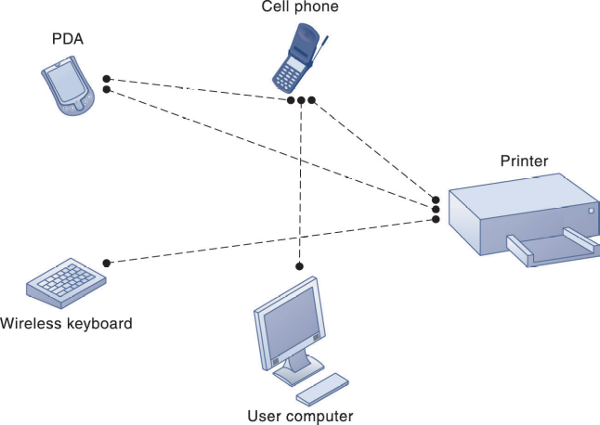

Fig 7.13 A Bluetooth Network (PAN)

Wi-Fi and Wireless Internet Access

We mentioned earlier that today’s computing environment should be referred to as “wireless.” The recent proliferation of wireless technology is technically known as the 802.11 networking standard. It’s more commonly, and easily, called Wi-Fi for wireless fidelity. Wi-Fi can be installed on your existing computers and connect them through a router hub via access points. If you have several computers at home or in the office, a Wi-Fi network can help save money by negating the need for additional phone lines for Internet access or to use a single peripheral device such as a printer among several different computers. Each computer requires a wireless NIC (network interface card) containing a built-in radio and antenna. These cards are relatively inexpensive and you can avoid duplicating more expensive equipment by using a wireless network.

You can access Wi-Fi networks in public areas such as libraries, Internet cafes, hotels, and airports. Access points to a wireless network are called hot spots and are proliferating in many public places. You should be aware of the dangers in using these hot spots. They lack strong security measures typical of wireless networks. You may experience interference problems as more users try to access the network.

One of the biggest challenges facing the Wi-Fi industry is creating enough hotspots all around the country to provide blanket coverage without interruption. Currently there are still not enough continuous connections and many times users are dropped without warning. It’s similar to the situation cell phones users have experienced with dropped calls and service interruptions.

WiMax

Unfortunately, there are still large regions of the United States that must continue to rely on old telephone systems for Internet access. That prevents users from taking advantage of new high-speed access and many of the feature-rich applications available on the Internet. And because of limitations in frequency ranges associated with Wi-Fi, Bluetooth, and other technologies, many users are left out of the Internet evolution. A new technology called WiMax is being developed to help fill the gaps all across the country. WiMax increases the range of transmissions up to approximately 30 miles and increases the transmission speeds significantly over that available on regular telephone lines and dial-up modems.

RFID and Wireless Sensor Networks

Radio Frequency Identification (RFID) and Near Field Communication (NFC)

Radio Frequency Identification (RFID) systems are an excellent example of how wireless technology is totally remaking supply chain management systems. RFID tags are small microchips that contain information about the product. In fact, NFL players now wear embedded RFID chips in their shoulder pads to collect and transmit data as the Interactive Session in Chapter 2 explained.

This technology holds a distinct advantage over the old bar codes because it doesn’t require line-of-sight readers. Instead the tags transmit data via radio frequencies to computing devices that track the product. The tags can be either active or passive. Let’s compare the characteristics of each:

- Active RFID tags: battery powered; data can be rewritten; have a longer read range, shorter operational life
- Passive RFID tags: no power source, smaller, lighter, and less expensive; unlimited operational lifetime; shorter read range

Figure 7.15 shows how the RFID technology works.

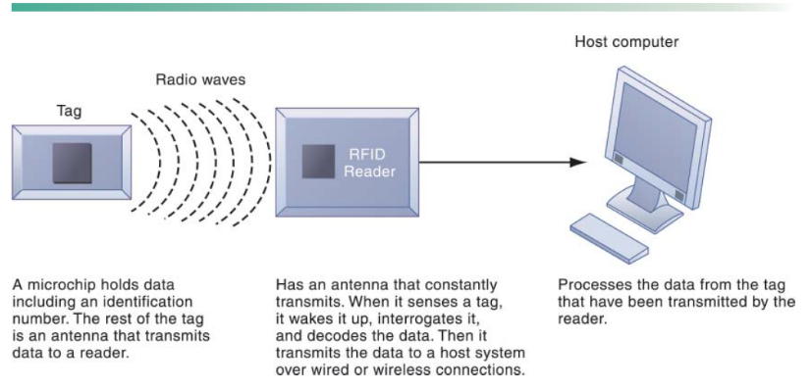
Figure 7.15: How RFID works.

RFID tags offer more inventory management control over products than the current bar code technology for several reasons:

- More data can be written to RFID tags
- More real-time data can be provided by RFID tags
- RFID tags can trigger other processes within the computer system
- RFID tags do not require line-of-sight readers

Even though RFID tags are more expensive than bar-code technologies, costs are dropping as they become more prevalent and the system switch-over is completed. For example, in 2001 a single RFID tag cost approximately $2.00.

RFID tags can cost as little as 10 cents or as much as $50 depending on the type of tag, the application and the volume of the order.
Generally speaking, finished smart labels that can be applied to cases and pallets typically cost 15 cents or more, depending on volume. Active tags – those with a battery – can cost far more. And, if you bundle in a sophisticated sensor, the cost can rise to more than $50 per tag.
However, the cost of the tag should not be the determining factor when looking at RFID technology. While some tags may cost upward of $50, the return on the investment may be tenfold. For instance, some railroad companies are using $40 tags that are mounted on rail cars. These tags can be reprogramed thousands of times, meaning the cost of each time that tag is read and written to is less than one cent. The ROI in this case is tremendous. (How much does an RFID tag cost? www.barcoding.com, copied March 22, 2019)

Near field communication (NFC) uses RFID technology that allows two devices to exchange data. It’s most commonly used in wireless payment services, to retrieve information or to exchange videos or information. It’s very common for people in European countries to wave a smart phone with NFC technology over a second device to pay for merchandise or services rather than the old-fashioned way of using a plastic credit card.

Wireless Sensor Networks

Businesses use wireless sensor networks (WSNs) to connect handheld devices with data storage devices and allow workers to roam untethered through warehouses and office buildings. In the long run, WSNs will be cheaper for businesses and homes because no structural changes will need to be made to the building’s walls, ceilings, or floors. If you want to add equipment, you’ll simply add another node to the network. You won’t have to cut holes, run wires, or alter the physical structure at all.

Wireless sensor networks and other networks send their output over an “Internet of Things” for analysis. Any object that generates data can be the focus of the Internet of Things.

“Internet of Things (IoTs) is an ecosystem of interconnected devices and objects accessible via the internet. In simple terms, The Things that are connected to each and can exchange digital information using the channel of the Internet.

Some common examples that you can relate to are your mobile electronic devices like laptops, mobiles. But, all of these are past developments. IoT has reached new heights with recent technological advancements and now we can add such objects to the IoT channel that could never have been imagined 10 years back.

Internet of Things (IoT) is not at its peak. Actually, it’s not even close to it. With 11.2 billion devices connected via IoT technology across the world, IoT is just in its adolescence. By the year 2020, the IoT industry is predicted to become more than a $3 trillion business. However, where did it all start?

Do you remember when your mobile phones became “Smart” Phones? That was the glorious day when IoT began its glorious journey. Although Simon (IBM), the first smartphone that was connected to the internet was launched in 1992, the term IoT was coined only a decade later in 2002. That is why every device that is connected via IoT technology is called a “smart” device. Kevin Ashton (father of IoT) says, “The Internet of Things has the potential to change the world, just as the Internet did. Maybe even more so.” This statement is soon to become a reality and this future looks bright and prosperous.

IoT is a disruptive technology similar to mobile phones. With the launch of mobile phones, the entire industry of pagers rolled out of existence, similarly in 10 years IoT will revise almost every present object that we interact with on a daily basis into an Internet enabled device. This will surely become the greatest technological migration after computers and smartphones.

So, if you are planning to make any big investments on home or office appliances. Just hold your horses for a while and reconsider your options. As all the present-day appliances will become worthless once their IoT enabled counterparts are launched.” (The Future of Technology: Internet of Things (IoT) IoT Advancements in 2018, www.excellentwebworld.com, Sagar, Paresh, copied March 22, 2019)

Bottom Line: Wireless technologies such as Bluetooth and Wi-Fi create small networks that connect just about any kind of computing device. They are easier to configure and connect than wired technologies and allow users more flexibility and access. Wireless access points, or hotspots, are springing up in airports, hotels, coffee shops, and rest stops all across the country and world. RFID technology is giving companies new opportunities and challenges for supply chain management.

7.5 How will MIS help my career?

The chapter’s elements and information can help in securing a good job as an automotive digital advisor. This position will run a digital marketing program for a large automotive dealership. These types of jobs are becoming more popular as information technology becomes more important in the workplace.

Discussion Questions:

- Discuss the advantages of a company using the TCP/IP standard to build a network.

- Discuss some of the Internet services available to businesses and how they can provide value.

- Discuss the emerging Voice over Internet Protocol (VoIP) technology and some of the advantages it may provide to businesses.

4. Use your imagination and come up with ideas of how your organization or company can use a wireless network. What current processes will you have to change to incorporate your idea?

5. Describe the advantages of using RFID tags rather than bar code technology.

Answers to Discussion Questions:

- The TCP/IP provides a universally agreed-on method for breaking up digital messages into packets, routing them to the proper addresses, and then reassembling them into coherent messages. Businesses using the TCP/IP standard can use a wide variety of hardware and software that is readily available thus sidestepping the need to create proprietary software and special hardware. Because of the universal acceptance of the TCP/IP standard, businesses can build networks that anyone anywhere can use.

- A few of the Internet services available to businesses include e-mail, wikis, electronic discussion groups, chatting, instant messaging, Telnet, FTP, and of course the World Wide Web. All of these services provide a universal method of connecting employees, customers, suppliers, and business partners in an inexpensive way.

- Voice over IP (VoIP) enables companies to use Internet technology for telephone voice transmission over the Internet or private networks. VoIP technology uses the Internet Protocol (IP) to deliver voice information in digital form using packet switching, avoiding the tolls charged by local and long-distance telephone networks. VoIP calls can be made and received with a desktop computer equipped with a microphone and speakers or with a VoIP-enabled telephone.

- Answers will vary but should include information about the benefits of linking functional areas of an organization to increase communication among co-workers and teams, making information more accessible to employees and suppliers, and reducing costs associated with disseminating information. Answers should address how to integrate wireless technology into the rest of the firm’s IT infrastructure, how to maintain security and privacy, and how the relationships among employees, customers, suppliers, and business partners will change.

- RFID tags provide wireless transmission of more data in a real-time mode than does bar code technology. The RFID tags can trigger other processes with an information system based on the data contained in the tag. Because RFID tags do not require line-of-sight readers, data transmissions are faster and easier.

